*Public Notice to run in Silsbee Bee newspaper for two consecutive weeks.*

*Notice should also be posted on County website, in County Courthouse, and other bulletin boards.*

*Please request a publisher’s affidavit from the Silsbee Bee*

*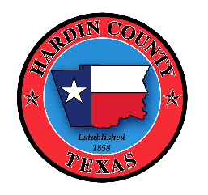*

PUBLIC NOTICE

NOTICE OF OPPORTUNITY TO APPLY FOR HARDIN COUNTY HURRICANE HARVEY CDBG-DR ACQUISITION PROGRAM

Hardin County is conducting a voluntary acquisition project for homes damaged during Hurricane Harvey. The project will be administered locally and overseen by the Texas General Land Office (GLO) Community Development & Revitalization Program (CDR). The project is funded through a Community Development Block Grant for Disaster Recovery (CDBG-DR).

The application period opened on March 24th, 2021 and the deadline to submit applications has been extended to September 1st, 2021.

The Intake Beneficiary Application, along with application instructions and frequently-asked questions are available on the County website at <http://www.co.hardin.tx.us/>. Paper applications are also available at the County Courthouse at 300 W Monroe St, Kountze, TX 77625.

Completed applications can be submitted to the following address:

Hardin County

Attn: CDBG-DR Acquisition

300 W Monroe St

Kountze, TX 77625

Or completed applications may be submitted online at [cdbg4332acq@co.hardin.tx.us](mailto:cdbg4332acq@co.hardin.tx.us).

Citizens with special needs or those who would like technical assistance may contact 512-202-1306.